**COGNIZANT**

**Week- Hands on**

**Assignments**

**Spring Core, Maven, Spring Data JPA**

**Name: *Lalith Kumar S***

**Super Set ID: *6372999***

**E-mail:**[***officiallalithkumar@gmail.com***](mailto:officiallalithkumar@gmail.com)

**Spring core Maven**

**Question-1(Configuring a Basic Spring Application)**

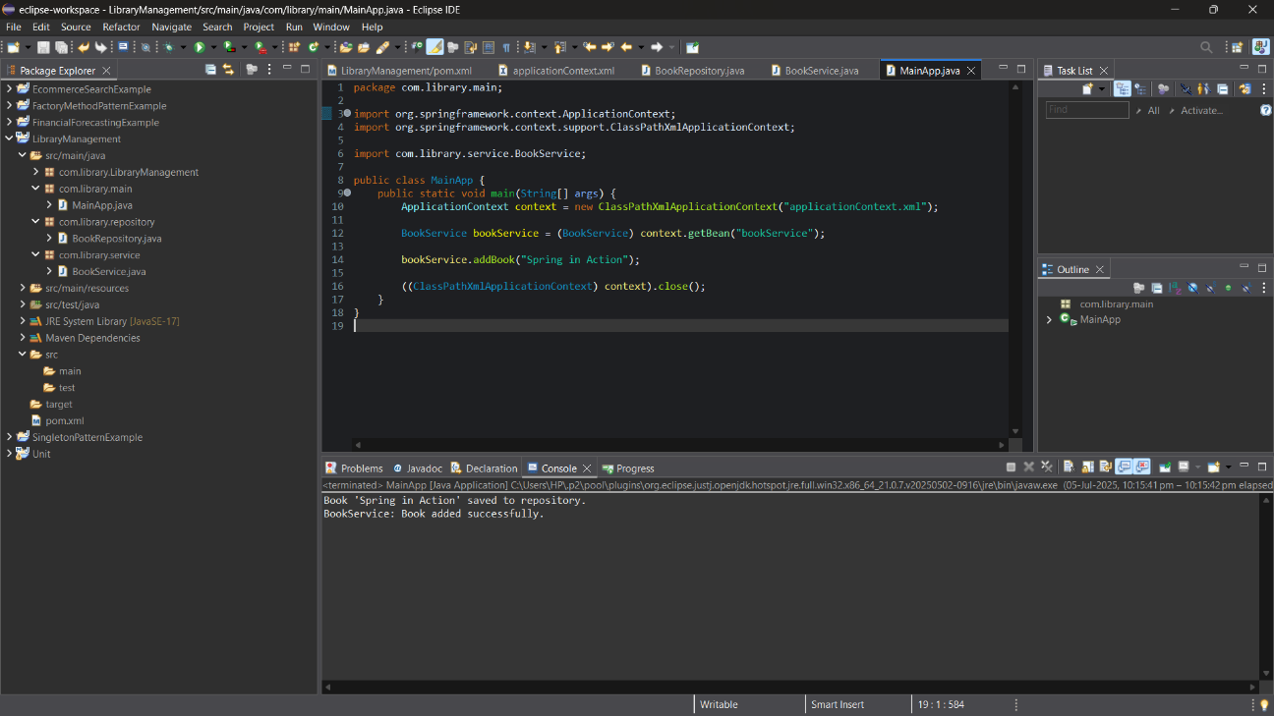

**Question-2(Implementing Dependency Injection)**

**applicationContent.xml**

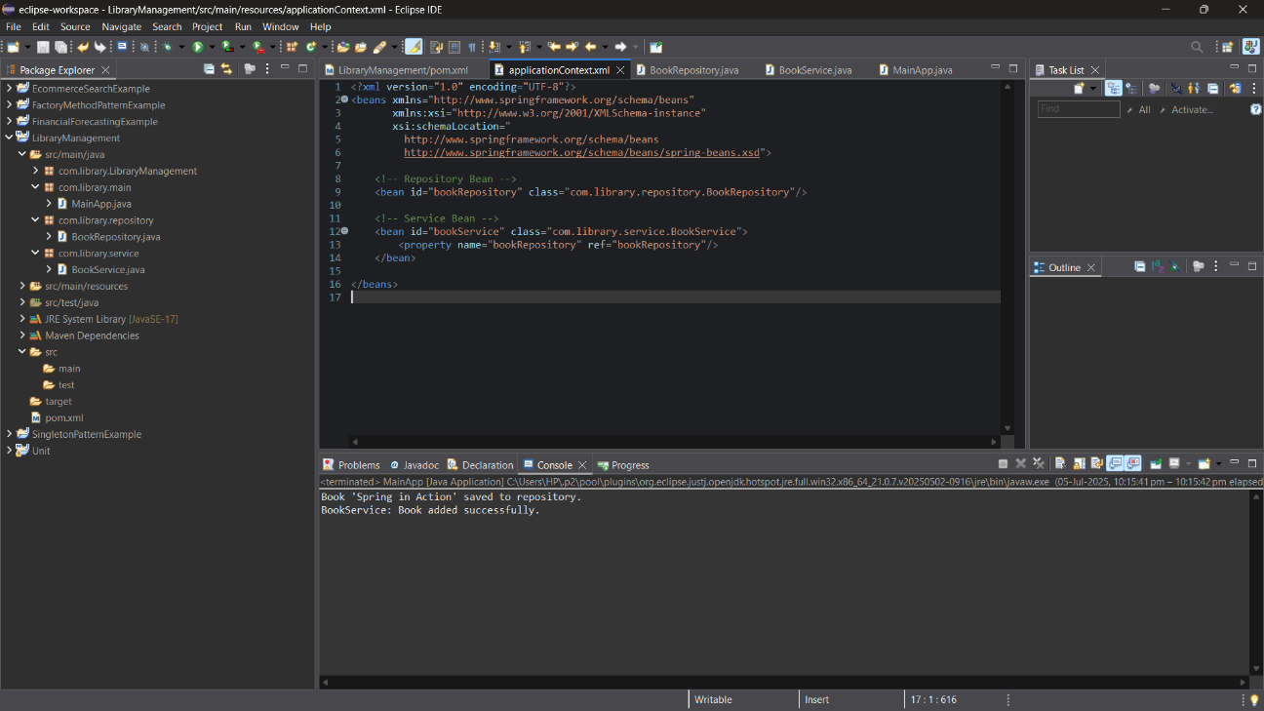

**BookService.java**

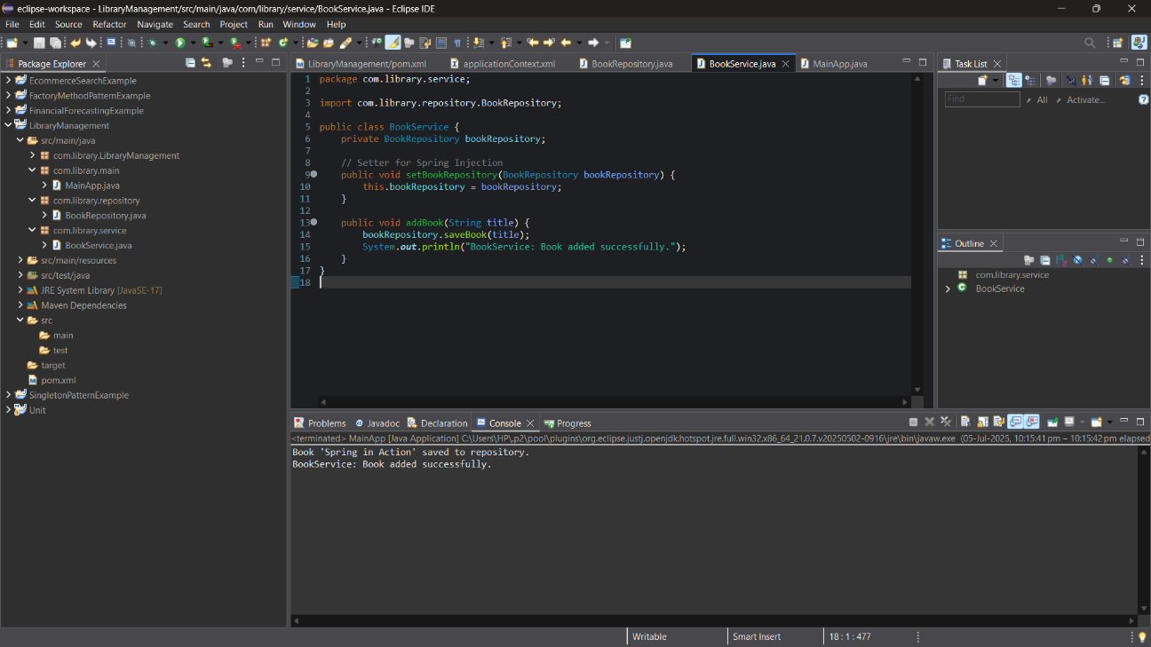

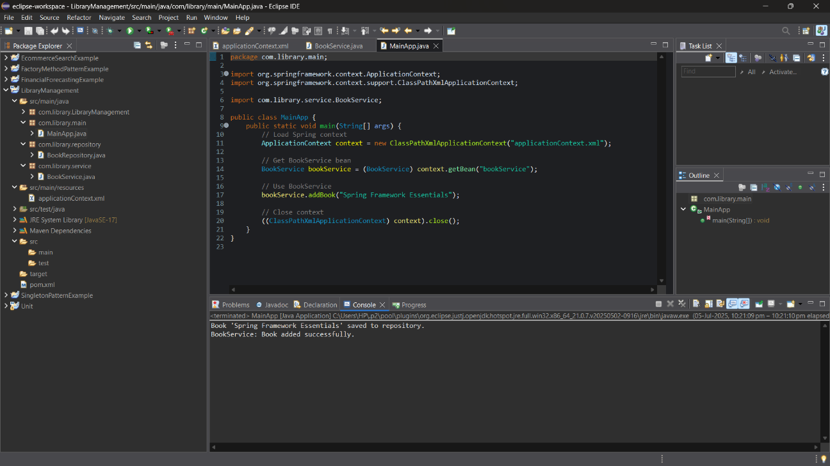**Main.java**

**Question-3(Creating and Configuring a Maven Project)**

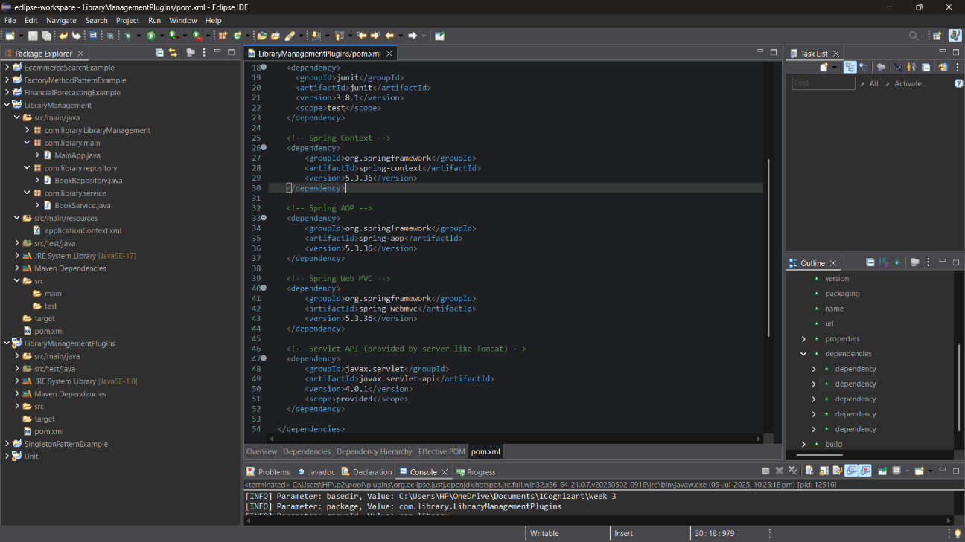**Pom.xml**

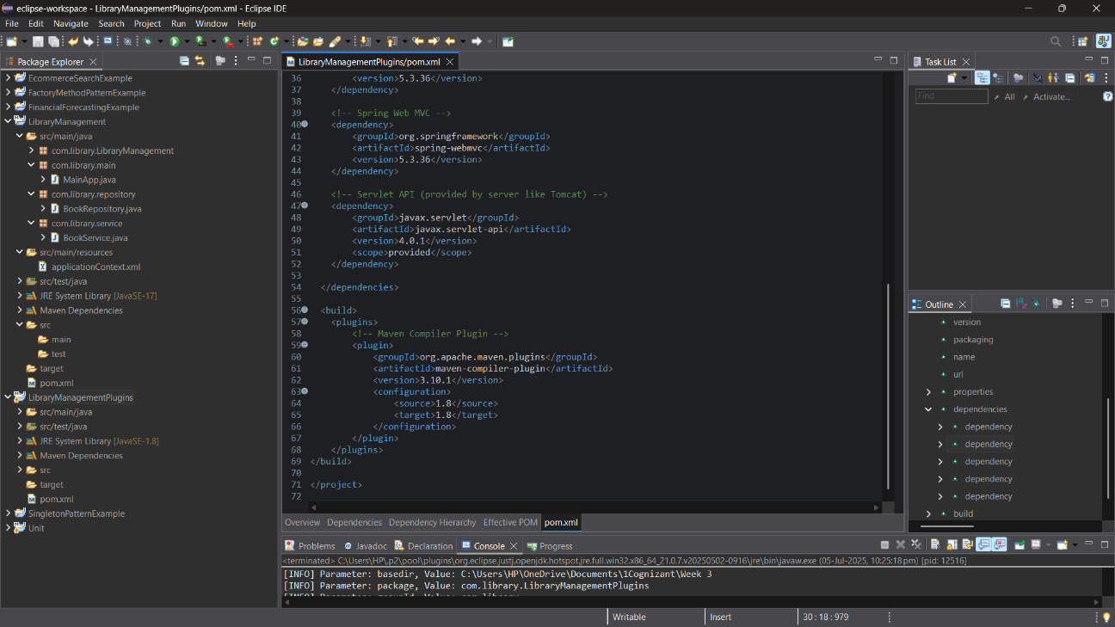

**Spring data JPA**

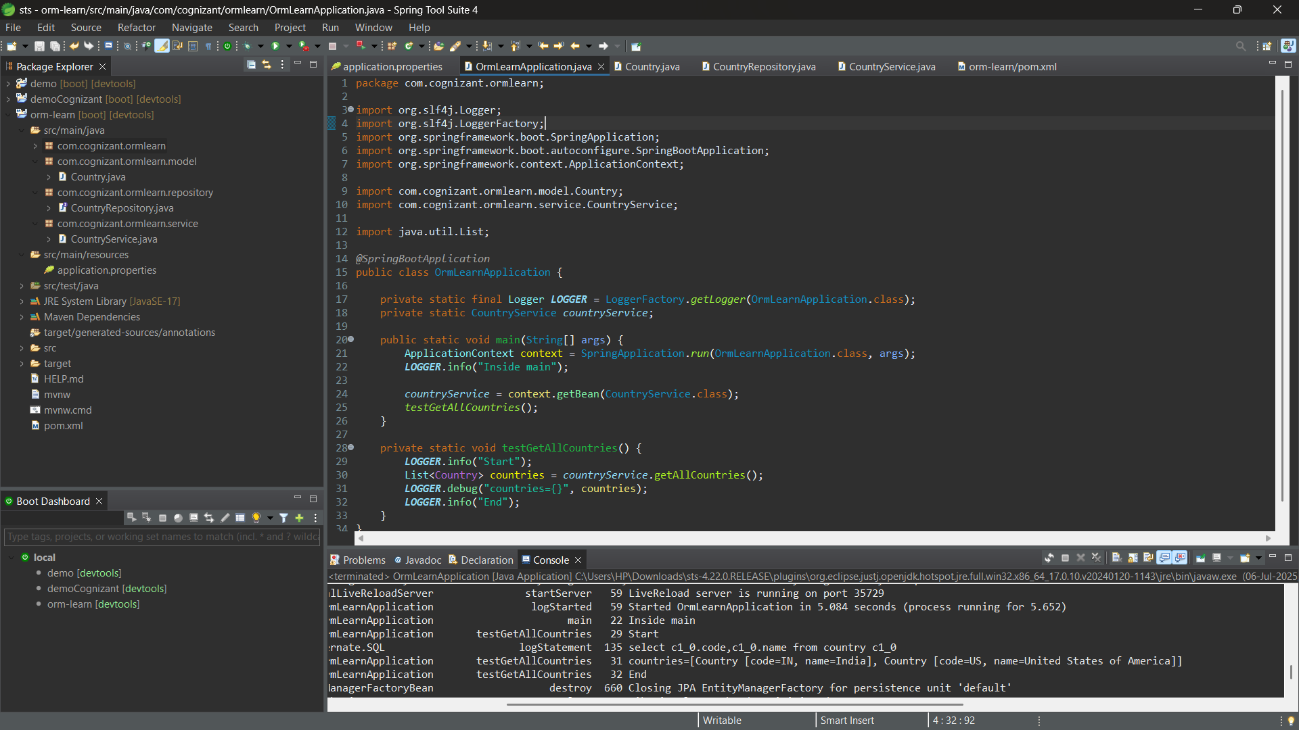**Question-4(Spring Data JPA - Quick Example)**

**Question-5(Difference between JPA, Hibernate and Spring Data JPA )**

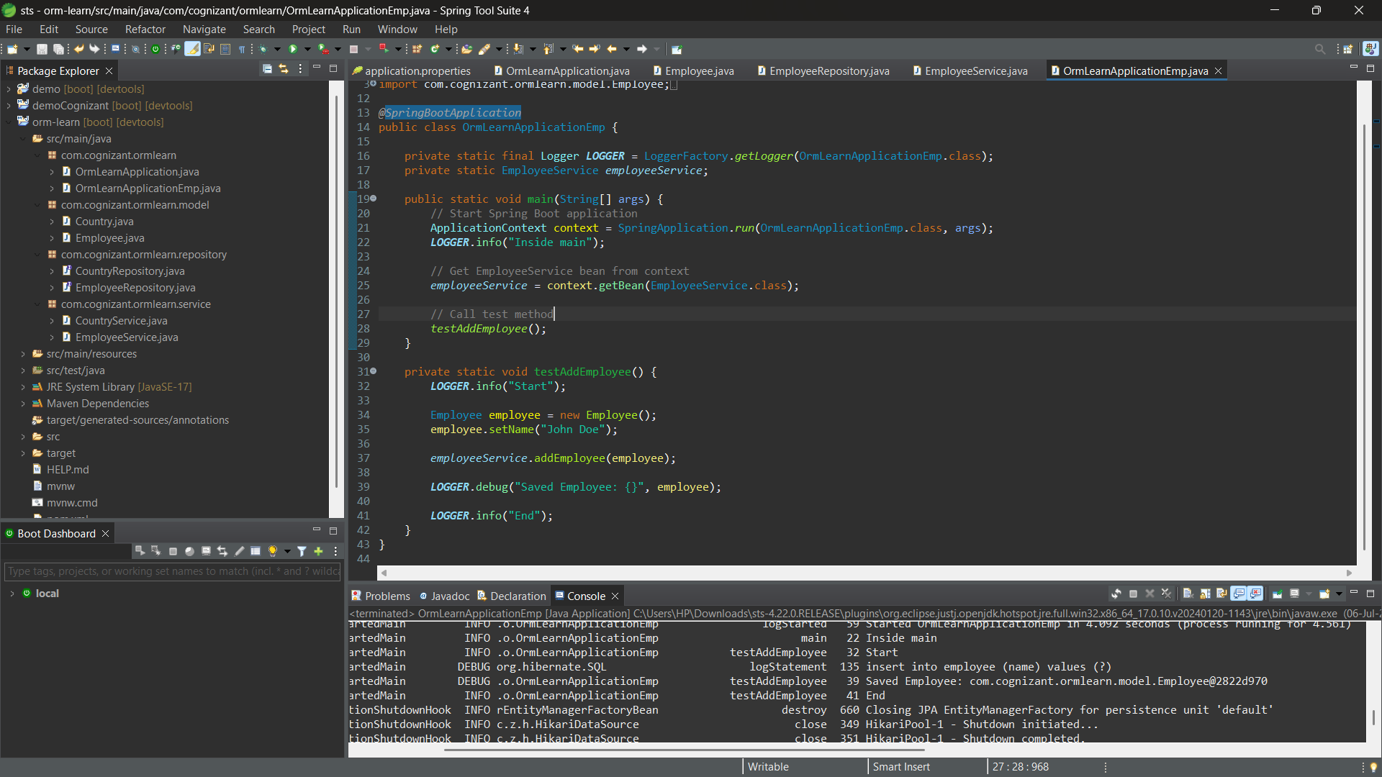**ormLearnApplication.java**

**Mysql Inserted Rows**

